domain enumeration

atg9999s.com

Whois
- whois scan on atg9999s.com
┌──(kali㉿kali)-[~]
└─$ whois atg9999s.com
Domain Name: ATG9999S.COM
Registry Domain ID: 2666292443_DOMAIN_COM-VRSN
Registrar WHOIS Server: whois.godaddy.com
Registrar URL: http://www.godaddy.com
Updated Date: 2022-10-06T00:22:29Z
Creation Date: 2022-01-05T20:23:49Z
Registry Expiry Date: 2032-01-05T20:23:49Z
Registrar: GoDaddy.com, LLC
Registrar IANA ID: 146
Registrar Abuse Contact Email: abuse@godaddy.com
Registrar Abuse Contact Phone: 480-624-2505
Domain Status: clientDeleteProhibited https://icann.org/epp#clientDeleteProhibited
Domain Status: clientRenewProhibited https://icann.org/epp#clientRenewProhibited
Domain Status: clientTransferProhibited https://icann.org/epp#clientTransferProhibited
Domain Status: clientUpdateProhibited https://icann.org/epp#clientUpdateProhibited
Name Server: LELAND.NS.CLOUDFLARE.COM
Name Server: OLLIE.NS.CLOUDFLARE.COM
DNSSEC: unsigned
URL of the ICANN Whois Inaccuracy Complaint Form: https://www.icann.org/wicf/
Last update of whois database: 2023-11-17T21:06:24Z
For more information on Whois status codes, please visit https://icann.org/epp
NOTICE: The expiration date displayed in this record is the date the
registrar's sponsorship of the domain name registration in the registry is
currently set to expire. This date does not necessarily reflect the expiration
date of the domain name registrant's agreement with the sponsoring
registrar. Users may consult the sponsoring registrar's Whois database to
view the registrar's reported date of expiration for this registration.
TERMS OF USE: You are not authorized to access or query our Whois
database through the use of electronic processes that are high-volume and
automated except as reasonably necessary to register domain names or
modify existing registrations; the Data in VeriSign Global Registry
Services' ("VeriSign") Whois database is provided by VeriSign for
information purposes only, and to assist persons in obtaining information
about or related to a domain name registration record. VeriSign does not
guarantee its accuracy. By submitting a Whois query, you agree to abide
by the following terms of use: You agree that you may use this Data only
for lawful purposes and that under no circumstances will you use this Data
to: (1) allow, enable, or otherwise support the transmission of mass
unsolicited, commercial advertising or solicitations via e-mail, telephone,
or facsimile; or (2) enable high volume, automated, electronic processes
that apply to VeriSign (or its computer systems). The compilation,
repackaging, dissemination or other use of this Data is expressly
prohibited without the prior written consent of VeriSign. You agree not to
use electronic processes that are automated and high-volume to access or
query the Whois database except as reasonably necessary to register
domain names or modify existing registrations. VeriSign reserves the right
to restrict your access to the Whois database in its sole discretion to ensure
operational stability. VeriSign may restrict or terminate your access to the
Whois database for failure to abide by these terms of use. VeriSign
reserves the right to modify these terms at any time.
The Registry database contains ONLY .COM, .NET, .EDU domains and
Registrars.
Domain Name: atg9999s.com
Registry Domain ID: 2666292443_DOMAIN_COM-VRSN
Registrar WHOIS Server: whois.godaddy.com
Registrar URL: https://www.godaddy.com
Updated Date: 2022-01-05T15:23:50Z
Creation Date: 2022-01-05T15:23:49Z
Registrar Registration Expiration Date: 2032-01-05T15:23:49Z
Registrar: GoDaddy.com, LLC
Registrar IANA ID: 146
Registrar Abuse Contact Email: abuse@godaddy.com
Registrar Abuse Contact Phone: +1.4806242505
Domain Status: clientTransferProhibited https://icann.org/epp#clientTransferProhibited
Domain Status: clientUpdateProhibited https://icann.org/epp#clientUpdateProhibited
Domain Status: clientRenewProhibited https://icann.org/epp#clientRenewProhibited
Domain Status: clientDeleteProhibited https://icann.org/epp#clientDeleteProhibited
Registry Registrant ID: Not Available From Registry
Registrant Name: Registration Private
Registrant Organization: Domains By Proxy, LLC
Registrant Street: DomainsByProxy.com
Registrant Street: 2155 E Warner Rd
Registrant City: Tempe
Registrant State/Province: Arizona
Registrant Postal Code: 85284
Registrant Country: US
Registrant Phone: +1.4806242599
Registrant Phone Ext:
Registrant Fax:
Registrant Fax Ext:
Registrant Email: Select Contact Domain Holder link at https://www.godaddy.com/whois/results.aspx?domain=atg9999s.com
Registry Admin ID: Not Available From Registry
Admin Name: Registration Private
Admin Organization: Domains By Proxy, LLC
Admin Street: DomainsByProxy.com
Admin Street: 2155 E Warner Rd
Admin City: Tempe
Admin State/Province: Arizona
Admin Postal Code: 85284
Admin Country: US
Admin Phone: +1.4806242599
Admin Phone Ext:
Admin Fax:
Admin Fax Ext:
Admin Email: Select Contact Domain Holder link at https://www.godaddy.com/whois/results.aspx?domain=atg9999s.com
Registry Tech ID: Not Available From Registry
Tech Name: Registration Private
Tech Organization: Domains By Proxy, LLC
Tech Street: DomainsByProxy.com
Tech Street: 2155 E Warner Rd
Tech City: Tempe
Tech State/Province: Arizona
Tech Postal Code: 85284
Tech Country: US
Tech Phone: +1.4806242599
Tech Phone Ext:
Tech Fax:
Tech Fax Ext:
Tech Email: Select Contact Domain Holder link at https://www.godaddy.com/whois/results.aspx?domain=atg9999s.com
Name Server: LELAND.NS.CLOUDFLARE.COM
Name Server: OLLIE.NS.CLOUDFLARE.COM
DNSSEC: unsigned
URL of the ICANN WHOIS Data Problem Reporting System: http://wdprs.internic.net/
Last update of WHOIS database: 2023-11-17T21:06:37Z
For more information on Whois status codes, please visit https://icann.org/epp
TERMS OF USE: The data contained in this registrar's Whois database, while believed by the
registrar to be reliable, is provided "as is" with no guarantee or warranties regarding its
accuracy. This information is provided for the sole purpose of assisting you in obtaining
information about domain name registration records. Any use of this data for any other purpose
is expressly forbidden without the prior written permission of this registrar. By submitting
an inquiry, you agree to these terms and limitations of warranty. In particular, you agree not
to use this data to allow, enable, or otherwise support the dissemination or collection of this
data, in part or in its entirety, for any purpose, such as transmission by e-mail, telephone,
postal mail, facsimile or other means of mass unsolicited, commercial advertising or solicitations
of any kind, including spam. You further agree not to use this data to enable high volume, automated
or robotic electronic processes designed to collect or compile this data for any purpose, including
mining this data for your own personal or commercial purposes. Failure to comply with these terms
may result in termination of access to the Whois database. These terms may be subject to modification
at any time without notice.
```
## nslookup
- results reveal domain ip address of 34.102.136.180
```bash
┌──(kali㉿kali)-[~]
└─$ nslookup atg9999s.com
Server: 24.154.1.12
Address: 24.154.1.12#53
Non-authoritative answer:
Name: atg9999s.com
Address: 34.102.136.180
Copy

crt.sh
- Searched on https://crt.sh for certificates associated with atg9999s.com and it's subdomains
  - results available at https://crt.sh/?q=atg9999s.com
  - reveals certs issued for the following subdomains
    - a9999.atg9999s.com
      - www.a9999.atg9999s.com
    - c9999.atg9999s.com
      - www.c9999.atg9999s.com
    - web1.atg9999s.com
    - *.atg9999s.com
  - 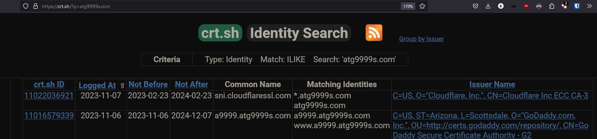
  - https://a9999.atg9999s.com
    - First domain I visited gave me an access denied screen
    - The website a9999.atg9999s.com may be banning all who connect
    - url changes to https://a9999.atg9999s.com/WCC2/Home/Login?ReturnUrl=%2fWCC2%2f
    - TRY SQL injection here
    - My home ip 24.101.113.252
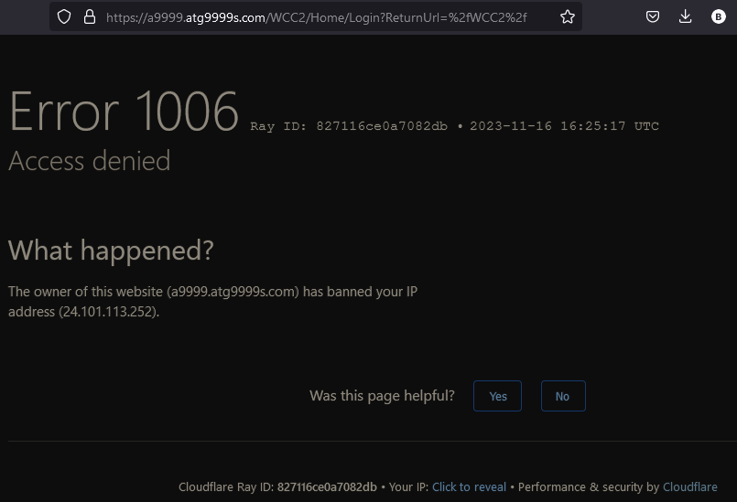
  - http://a9999.atg9999s.com
    - An Error 522 means that the request was able to connect to your web server, but that the request didn't finish.
    - 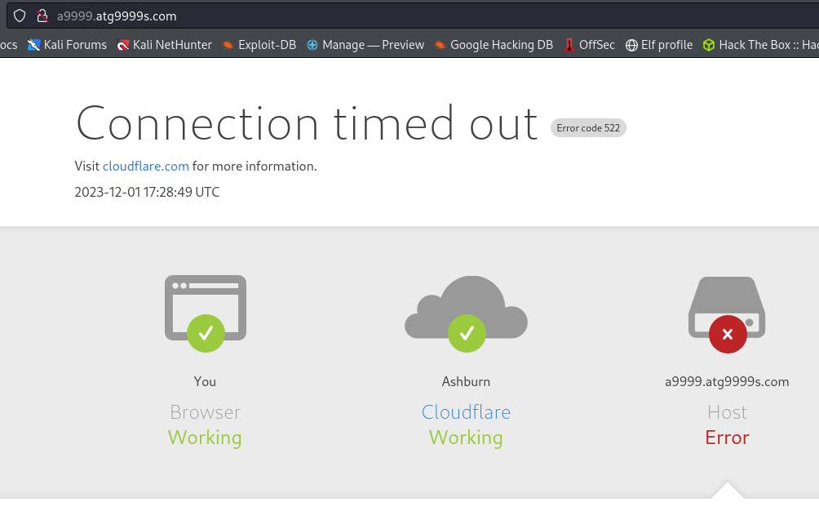
  - www.a9999.atg9999s.com
    - 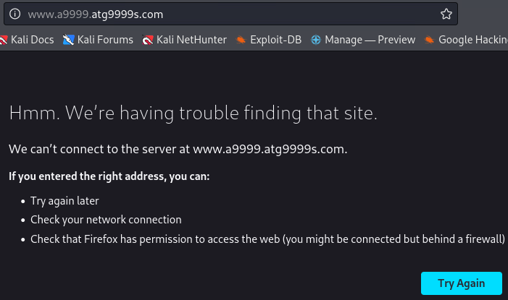
  - *.atg9999s.com
    - does not resolve
  - atg9999s.com
    - Parked by GoDaddy.com
    - 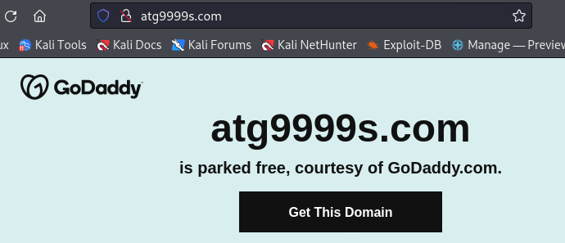
  - web1.atg9999s.com
    - 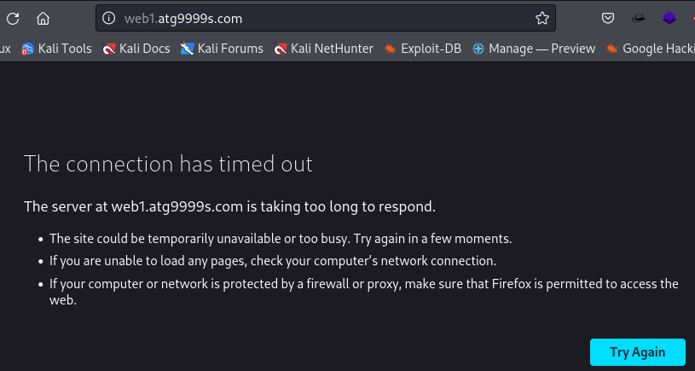
  - http://www.web1.atg9999s.com and https://www.web1.atg9999s.com
    - does not resolve
    - 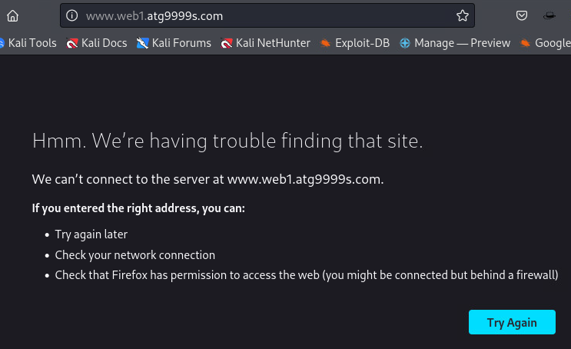
  - https://web1.atg9999s.com
    - reveals asp.net home page
    - 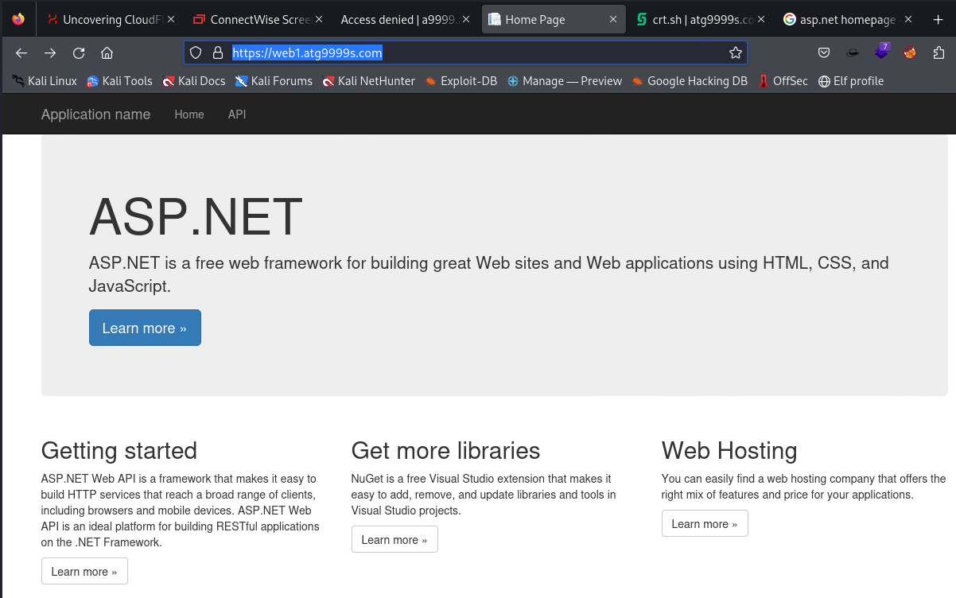
  - http://c9999.atg9999s.com
    - 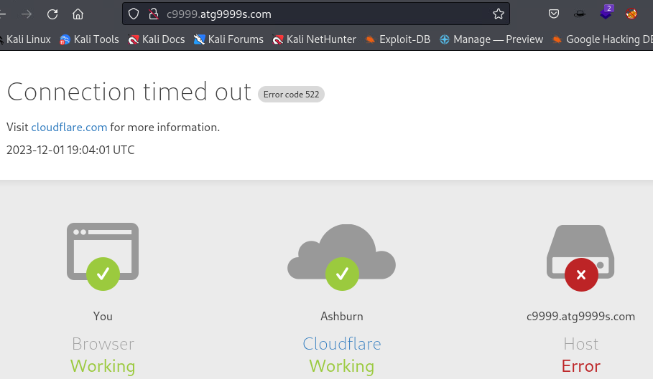
  - https://c9999.atg9999s.com
    - Reveals ConnectWise ScreenConnect
    - 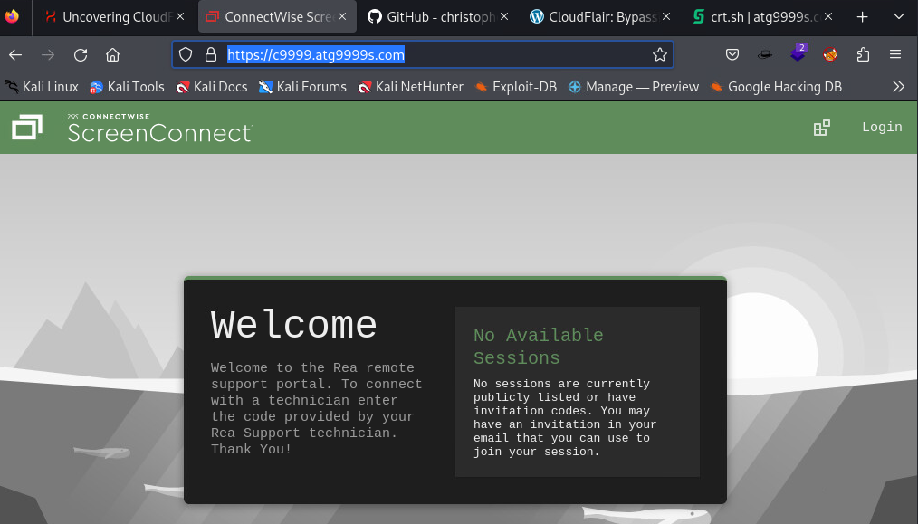
  - www.c9999.atg9999s.com

Scanning atg9999s.com subdomains with CloudFlair
- CloudFlair https://github.com/christophetd/CloudFlair
  - Finds the origin servers of websites protected by CloudFlare (or CloudFront) which are publicly exposed and don't appropriately restrict network access to the relevant CDN IP ranges.
  - Uses Internet-wide scan data from Censys to find exposed IPv4 hosts presenting an SSL certificate associated with the target's domain name.
- Ran CloudFlair on a9999.atg9999s.com and c9999.atg9999s.com - Target
- Copy
┌──(venv)─(kali㉿kali)-[~/CloudFlair]
└─$ python3 cloudflair.py a9999.atg9999s.com
[*] Retrieving Cloudflare IP ranges from https://www.cloudflare.com/ips-v4
[*] The target appears to be behind CloudFlare.
[*] Looking for certificates matching "a9999.atg9999s.com" using Censys
[*] 3 certificates matching "a9999.atg9999s.com" found.
[*] Looking for IPv4 hosts presenting these certificates...
[*] 0 IPv4 hosts presenting a certificate issued to "a9999.atg9999s.com" were found.
[-] The target is most likely not vulnerable.
┌──(venv)─(kali㉿kali)-[~/CloudFlair]
└─$ python3 cloudflair.py c9999.atg9999s.com
[*] Retrieving Cloudflare IP ranges from https://www.cloudflare.com/ips-v4
[*] The target appears to be behind CloudFlare.
[*] Looking for certificates matching "c9999.atg9999s.com" using Censys
[*] 4 certificates matching "c9999.atg9999s.com" found.
[*] Looking for IPv4 hosts presenting these certificates...
[*] 0 IPv4 hosts presenting a certificate issued to "c9999.atg9999s.com" were found.
[-] The target is most likely not vulnerable.
Copy
- navigating to the TLD http://atg9999s.com and godaddy advertises that the domain is parked free
  - Parked for free means that the owner of the domain name hasn’t developed a site yet and temporarily he uses his domain registrar’s (ex. Godaddy) nameservers. Registrars usually promote their services on parked domains or they show ads.
- clicking through godaddy link reveals that the domain is not available. But could be?
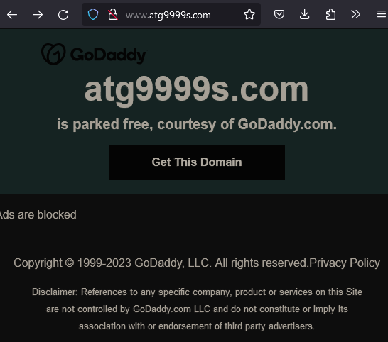

34.102.136.180 scans
- PING
┌──(kali㉿kali)-[~]
└─$ ping atg9999s.com
PING atg9999s.com (34.102.136.180) 56(84) bytes of data.
64 bytes from 180.136.102.34.bc.googleusercontent.com (34.102.136.180): icmp_seq=1 ttl=117 time=21.3 ms
64 bytes from 180.136.102.34.bc.googleusercontent.com (34.102.136.180): icmp_seq=2 ttl=117 time=20.0 ms
64 bytes from 180.136.102.34.bc.googleusercontent.com (34.102.136.180): icmp_seq=3 ttl=117 time=22.6 ms
64 bytes from 180.136.102.34.bc.googleusercontent.com (34.102.136.180): icmp_seq=4 ttl=117 time=16.6 ms
64 bytes from 180.136.102.34.bc.googleusercontent.com (34.102.136.180): icmp_seq=5 ttl=117 time=14.7 ms
64 bytes from 180.136.102.34.bc.googleusercontent.com (34.102.136.180): icmp_seq=6 ttl=117 time=23.5 ms
^C
--- atg9999s.com ping statistics ---
6 packets transmitted, 6 received, 0% packet loss, time 9103ms
rtt min/avg/max/mdev = 14.692/19.766/23.485/3.167 ms
Copy
- NMAP
- Need to run nmap to scan the ip but I'm concerned about being detected
- modifying my normal nmap scan down to avoid detection
- I couldn't remember the top 100 most common ports and discovered port 100 filtered with newacct service running on it.
┌──(root💀RCS-Response1)-[~]
└─# nmap -p100 -T2 -v -Pn 34.102.136.180
Host discovery disabled (-Pn). All addresses will be marked 'up' and scan times will be slower.
Starting Nmap 7.91 ( https://nmap.org ) at 2023-11-18 12:48 EST
Initiating Parallel DNS resolution of 1 host. at 12:48
Completed Parallel DNS resolution of 1 host. at 12:48, 0.09s elapsed
Initiating SYN Stealth Scan at 12:48
Scanning 180.136.102.34.bc.googleusercontent.com (34.102.136.180) [1 port]
Completed SYN Stealth Scan at 12:48, 2.41s elapsed (1 total ports)
Nmap scan report for 180.136.102.34.bc.googleusercontent.com (34.102.136.180)
Host is up.
PORT STATE SERVICE
100/tcp filtered newacct
Read data files from: /usr/bin/../share/nmap
Nmap done: 1 IP address (1 host up) scanned in 2.68 seconds
Raw packets sent: 2 (88B) | Rcvd: 0 (0B)
Copy
- -F top 100 most common ports scan reveals 80 and 443 open
┌──(root💀RCS-Response1)-[~]
└─# nmap -F -T2 -v -Pn 34.102.136.180
Host discovery disabled (-Pn). All addresses will be marked 'up' and scan times will be slower.
Starting Nmap 7.91 ( https://nmap.org ) at 2023-11-18 12:49 EST
Initiating Parallel DNS resolution of 1 host. at 12:49
Completed Parallel DNS resolution of 1 host. at 12:49, 0.02s elapsed
Initiating SYN Stealth Scan at 12:49
Scanning 180.136.102.34.bc.googleusercontent.com (34.102.136.180) [100 ports]
Discovered open port 80/tcp on 34.102.136.180
Discovered open port 443/tcp on 34.102.136.180
SYN Stealth Scan Timing: About 26.50% done; ETC: 12:51 (0:01:26 remaining)
SYN Stealth Scan Timing: About 60.50% done; ETC: 12:51 (0:00:40 remaining)
Completed SYN Stealth Scan at 12:51, 98.23s elapsed (100 total ports)
Nmap scan report for 180.136.102.34.bc.googleusercontent.com (34.102.136.180)
Host is up (0.089s latency).
Not shown: 98 filtered ports
PORT STATE SERVICE
80/tcp open http
443/tcp open https
Read data files from: /usr/bin/../share/nmap
Nmap done: 1 IP address (1 host up) scanned in 98.38 seconds
Raw packets sent: 217 (9.548KB) | Rcvd: 20 (880B)
Copy
- I also ran a long slow scan over the weekend to attempt to avoid detection.
┌──(root💀RCS-Response1)-[~]
└─# nmap -p- -T2 -v -Pn 34.102.136.180
Host discovery disabled (-Pn). All addresses will be marked 'up' and scan times will be slower.
Starting Nmap 7.91 ( https://nmap.org ) at 2023-11-18 14:20 EST
Initiating Parallel DNS resolution of 1 host. at 14:20
Completed Parallel DNS resolution of 1 host. at 14:20, 0.09s elapsed
Initiating SYN Stealth Scan at 14:20
Scanning 180.136.102.34.bc.googleusercontent.com (34.102.136.180) [65535 ports]
Discovered open port 443/tcp on 34.102.136.180
Discovered open port 80/tcp on 34.102.136.180
Increasing send delay for 34.102.136.180 from 400 to 800 due to 13 out of 43 dropped probes since last increase.
SYN Stealth Scan Timing: About 0.30% done
SYN Stealth Scan Timing: About 0.32% done
SYN Stealth Scan Timing: About 0.33% done
SYN Stealth Scan Timing: About 0.34% done
SYN Stealth Scan Timing: About 0.35% done
SYN Stealth Scan Timing: About 0.36% done
SYN Stealth Scan Timing: About 0.38% done
SYN Stealth Scan Timing: About 0.39% done
SYN Stealth Scan Timing: About 0.41% done
SYN Stealth Scan Timing: About 0.42% done
SYN Stealth Scan Timing: About 0.44% done
SYN Stealth Scan Timing: About 0.45% done
SYN Stealth Scan Timing: About 0.48% done
SYN Stealth Scan Timing: About 0.49% done
SYN Stealth Scan Timing: About 0.51% done
SYN Stealth Scan Timing: About 0.53% done
SYN Stealth Scan Timing: About 0.56% done
SYN Stealth Scan Timing: About 0.58% done
SYN Stealth Scan Timing: About 0.61% done
SYN Stealth Scan Timing: About 0.64% done
SYN Stealth Scan Timing: About 0.66% done
SYN Stealth Scan Timing: About 0.68% done
SYN Stealth Scan Timing: About 0.71% done
SYN Stealth Scan Timing: About 0.73% done
SYN Stealth Scan Timing: About 0.76% done
SYN Stealth Scan Timing: About 0.78% done
SYN Stealth Scan Timing: About 0.81% done
SYN Stealth Scan Timing: About 0.83% done
SYN Stealth Scan Timing: About 0.86% done
SYN Stealth Scan Timing: About 0.89% done
SYN Stealth Scan Timing: About 0.91% done
SYN Stealth Scan Timing: About 0.94% done
SYN Stealth Scan Timing: About 0.96% done
SYN Stealth Scan Timing: About 0.99% done
SYN Stealth Scan Timing: About 1.01% done; ETC: 05:04 (38:20:32 remaining)
SYN Stealth Scan Timing: About 1.41% done; ETC: 03:16 (36:23:54 remaining)
SYN Stealth Scan Timing: About 2.80% done; ETC: 01:53 (34:32:59 remaining)
SYN Stealth Scan Timing: About 4.47% done; ETC: 00:39 (32:46:08 remaining)
Stats: 2:21:06 elapsed; 0 hosts completed (1 up), 1 undergoing SYN Stealth Scan
SYN Stealth Scan Timing: About 7.02% done; ETC: 23:52 (31:10:12 remaining)
SYN Stealth Scan Timing: About 11.28% done; ETC: 23:35 (29:29:38 remaining)
SYN Stealth Scan Timing: About 16.53% done; ETC: 23:41 (27:49:52 remaining)
SYN Stealth Scan Timing: About 21.01% done; ETC: 23:28 (26:09:44 remaining)
SYN Stealth Scan Timing: About 26.12% done; ETC: 23:31 (24:30:22 remaining)
adjust_timeouts2: packet supposedly had rtt of 8448282 microseconds. Ignoring time.
adjust_timeouts2: packet supposedly had rtt of 8448282 microseconds. Ignoring time.
SYN Stealth Scan Timing: About 30.88% done; ETC: 23:24 (22:50:51 remaining)
SYN Stealth Scan Timing: About 35.86% done; ETC: 23:23 (21:11:37 remaining)
SYN Stealth Scan Timing: About 40.78% done; ETC: 23:20 (19:32:28 remaining)
SYN Stealth Scan Timing: About 45.63% done; ETC: 23:15 (17:53:28 remaining)
SYN Stealth Scan Timing: About 50.52% done; ETC: 23:10 (16:14:43 remaining)
SYN Stealth Scan Timing: About 55.44% done; ETC: 23:06 (14:36:13 remaining)
SYN Stealth Scan Timing: About 60.41% done; ETC: 23:05 (12:57:52 remaining)
SYN Stealth Scan Timing: About 65.37% done; ETC: 23:03 (11:19:35 remaining)
SYN Stealth Scan Timing: About 70.34% done; ETC: 23:01 (9:41:24 remaining)
SYN Stealth Scan Timing: About 75.32% done; ETC: 22:58 (8:03:21 remaining)
SYN Stealth Scan Timing: About 80.31% done; ETC: 22:58 (6:25:25 remaining)
SYN Stealth Scan Timing: About 85.32% done; ETC: 22:59 (4:47:31 remaining)
SYN Stealth Scan Timing: About 90.32% done; ETC: 22:58 (3:09:34 remaining)
SYN Stealth Scan Timing: About 95.32% done; ETC: 22:58 (1:31:38 remaining)
Completed SYN Stealth Scan at 22:57, 117409.93s elapsed (65535 total ports)
Nmap scan report for 180.136.102.34.bc.googleusercontent.com (34.102.136.180)
Host is up (0.052s latency).
Not shown: 65533 filtered ports
PORT STATE SERVICE
80/tcp open http
443/tcp open https
Read data files from: /usr/bin/../share/nmap
Nmap done: 1 IP address (1 host up) scanned in 117410.13 seconds
Raw packets sent: 144174 (6.344MB) | Rcvd: 13143 (578.292KB)
Copy
- Another nmap scan to detect versions running on open ports.
- 80 openresty and 443 tcpwrapped but could not detect versions
- robots.txt exists
┌──(kali㉿kali)-[~]
└─$ nmap -p 80,443 -A 34.102.136.180
Starting Nmap 7.94 ( https://nmap.org ) at 2023-11-20 07:09 EST
Stats: 0:00:28 elapsed; 0 hosts completed (1 up), 1 undergoing Service Scan
Service scan Timing: About 50.00% done; ETC: 07:10 (0:00:28 remaining)
Stats: 0:00:43 elapsed; 0 hosts completed (1 up), 1 undergoing Service Scan
Service scan Timing: About 50.00% done; ETC: 07:11 (0:00:43 remaining)
Nmap scan report for 180.136.102.34.bc.googleusercontent.com (34.102.136.180)
Host is up (0.022s latency).
PORT STATE SERVICE VERSION
80/tcp open http openresty
| http-robots.txt: 1 disallowed entry
|_/
|_http-server-header: openresty
|_http-title: Site doesn't have a title (text/html).
| fingerprint-strings:
| FourOhFourRequest:
| HTTP/1.0 403 Forbidden
| Server: openresty
| Date: Mon, 20 Nov 2023 16:58:03 GMT
| Content-Type: text/html
| Content-Length: 291
| ETag: "6552adee-123"
| Via: 1.1 google
| <!DOCTYPE html>
| <html lang="en">
| <head>
| <meta http-equiv="content-type" content="text/html;charset=utf-8" />
| <link rel="shortcut icon" href="data:image/x-icon;," type="image/x-icon" />
| <title>Forbidden</title>
| </head>
| <body>
| <h1>Access Forbidden</h1>
| </body>
| </html>
| GetRequest:
| HTTP/1.0 403 Forbidden
| Server: openresty
| Date: Mon, 20 Nov 2023 16:57:58 GMT
| Content-Type: text/html
| Content-Length: 291
| ETag: "6552adee-123"
| Via: 1.1 google
| <!DOCTYPE html>
| <html lang="en">
| <head>
| <meta http-equiv="content-type" content="text/html;charset=utf-8" />
| <link rel="shortcut icon" href="data:image/x-icon;," type="image/x-icon" />
| <title>Forbidden</title>
| </head>
| <body>
| <h1>Access Forbidden</h1>
| </body>
| </html>
| HTTPOptions:
| HTTP/1.0 403 Forbidden
| Server: openresty
| Date: Mon, 20 Nov 2023 16:57:58 GMT
| Content-Type: text/html
| Content-Length: 150
| Via: 1.1 google
| <html>
| <head><title>403 Forbidden</title></head>
| <body>
| <center><h1>403 Forbidden</h1></center>
| <hr><center>openresty</center>
| </body>
| </html>
| RTSPRequest:
| HTTP/1.0 400 Bad Request
| Content-Type: text/html; charset=UTF-8
| Referrer-Policy: no-referrer
| Content-Length: 273
| Date: Mon, 20 Nov 2023 16:57:58 GMT
| <html><head>
| <meta http-equiv="content-type" content="text/html;charset=utf-8">
| <title>400 Bad Request</title>
| </head>
| <body text=#000000 bgcolor=#ffffff>
| <h1>Error: Bad Request</h1>
| <h2>Your client has issued a malformed or illegal request.</h2>
| <h2></h2>
|_ </body></html>
443/tcp open tcpwrapped
1 service unrecognized despite returning data. If you know the service/version, please submit the following fingerprint at https://nmap.org/cgi-bin/submit.cgi?new-service :
SF-Port80-TCP:V=7.94%I=7%D=11/20%Time=655B4C8A%P=x86_64-pc-linux-gnu%r(Get
SF:Request,1CA,"HTTP/1\.0\x20403\x20Forbidden\r\nServer:\x20openresty\r\nD
SF:ate:\x20Mon,\x2020\x20Nov\x202023\x2016:57:58\x20GMT\r\nContent-Type:\x
SF:20text/html\r\nContent-Length:\x20291\r\nETag:\x20\"6552adee-123\"\r\nV
SF:ia:\x201\.1\x20google\r\n\r\n<!DOCTYPE\x20html>\n<html\x20lang=\"en\">\
SF:n\x20\x20<head>\n\x20\x20\x20\x20<meta\x20http-equiv=\"content-type\"\x
SF:20content=\"text/html;charset=utf-8\"\x20/>\n\x20\x20\x20\x20<link\x20r
SF:el=\"shortcut\x20icon\"\x20href=\"data:image/x-icon;,\"\x20type=\"image
SF:/x-icon\"\x20/>\n\x20\x20\x20\x20<title>Forbidden</title>\n\x20\x20</he
SF:ad>\n\x20\x20<body>\n\x20\x20\x20\x20<h1>Access\x20Forbidden</h1>\n\x20
SF:\x20</body>\n</html>\n")%r(HTTPOptions,127,"HTTP/1\.0\x20403\x20Forbidd
SF:en\r\nServer:\x20openresty\r\nDate:\x20Mon,\x2020\x20Nov\x202023\x2016:
SF:57:58\x20GMT\r\nContent-Type:\x20text/html\r\nContent-Length:\x20150\r\
SF:nVia:\x201\.1\x20google\r\n\r\n<html>\r\n<head><title>403\x20Forbidden<
SF:/title></head>\r\n<body>\r\n<center><h1>403\x20Forbidden</h1></center>\
SF:r\n<hr><center>openresty</center>\r\n</body>\r\n</html>\r\n")%r(RTSPReq
SF:uest,1AD,"HTTP/1\.0\x20400\x20Bad\x20Request\r\nContent-Type:\x20text/h
SF:tml;\x20charset=UTF-8\r\nReferrer-Policy:\x20no-referrer\r\nContent-Len
SF:gth:\x20273\r\nDate:\x20Mon,\x2020\x20Nov\x202023\x2016:57:58\x20GMT\r\
SF:n\r\n\n<html><head>\n<meta\x20http-equiv=\"content-type\"\x20content=\"
SF:text/html;charset=utf-8\">\n<title>400\x20Bad\x20Request</title>\n</hea
SF:d>\n<body\x20text=#000000\x20bgcolor=#ffffff>\n<h1>Error:\x20Bad\x20Req
SF:uest</h1>\n<h2>Your\x20client\x20has\x20issued\x20a\x20malformed\x20or\
SF:x20illegal\x20request\.</h2>\n<h2></h2>\n</body></html>\n")%r(FourOhFou
SF:rRequest,1CA,"HTTP/1\.0\x20403\x20Forbidden\r\nServer:\x20openresty\r\n
SF:Date:\x20Mon,\x2020\x20Nov\x202023\x2016:58:03\x20GMT\r\nContent-Type:\
SF:x20text/html\r\nContent-Length:\x20291\r\nETag:\x20\"6552adee-123\"\r\n
SF:Via:\x201\.1\x20google\r\n\r\n<!DOCTYPE\x20html>\n<html\x20lang=\"en\">
SF:\n\x20\x20<head>\n\x20\x20\x20\x20<meta\x20http-equiv=\"content-type\"\
SF:x20content=\"text/html;charset=utf-8\"\x20/>\n\x20\x20\x20\x20<link\x20
SF:rel=\"shortcut\x20icon\"\x20href=\"data:image/x-icon;,\"\x20type=\"imag
SF:e/x-icon\"\x20/>\n\x20\x20\x20\x20<title>Forbidden</title>\n\x20\x20</h
SF:ead>\n\x20\x20<body>\n\x20\x20\x20\x20<h1>Access\x20Forbidden</h1>\n\x2
SF:0\x20</body>\n</html>\n");
Copy
- robots.txt reveals
- user-agents - specifies rules for specific web crawlers, Googlebot, Bingbot, Slurp and Baiduspider
- Crawl-delay - permitted to crawl with a delay of 10 sec between requests
- Disallow: blank no specific paths are disallowed for theses bots
- user-agent: * - all others
- Disallow: / - not permitted to crawl any part of the site
- Consider Disallowing all web crawlers to ensure that any bot regardless of it's identity, is barred from accessing any part of the domain.
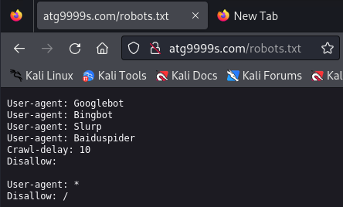
- MetaSploit and SearchSploit
- Quick search on metasploit and searchsploit for openresty and tcpwrapped open did not yield any existing vulnerabilities.
┌──(kali㉿kali)-[~]
└─$ msfconsole
, ,
/ \ ((__---,,,---__)) (_) O O (_)_________ \ _ / |\ o_o \ M S F | \ \ _____ | * ||| WW||| ||| |||
=[ metasploit v6.3.31-dev ]
+ -- --=[ 2346 exploits - 1220 auxiliary - 413 post ]
+ -- --=[ 1390 payloads - 46 encoders - 11 nops ]
+ -- --=[ 9 evasion ]
Metasploit tip: Display the Framework log using the
log command, learn more with help log
Metasploit Documentation: https://docs.metasploit.com/
msf6 > search openresty
[-] No results from search
msf6 > tcpwrapped
[-] Unknown command: tcpwrapped
msf6 > search tcpwrapped
[-] No results from search
msf6 > exit
┌──(kali㉿kali)-[~]
└─$ searchsploit openresty
Exploits: No Results
Shellcodes: No Results
Copy

ping c9999.atg9999s.com
- reveals another ip address 104.26.0.29
┌──(venv)─(kali㉿kali)-[~/CloudFlair]
└─$ ping c9999.atg9999s.com
PING c9999.atg9999s.com (104.26.0.29) 56(84) bytes of data.
64 bytes from 104.26.0.29 (104.26.0.29): icmp_seq=1 ttl=52 time=33.8 ms
64 bytes from 104.26.0.29 (104.26.0.29): icmp_seq=2 ttl=52 time=26.9 ms
64 bytes from 104.26.0.29 (104.26.0.29): icmp_seq=3 ttl=52 time=54.1 ms
^C
--- c9999.atg9999s.com ping statistics ---
3 packets transmitted, 3 received, 0% packet loss, time 2003ms
rtt min/avg/max/mdev = 26.891/38.258/54.101/11.550 ms
Copy

whois 104.26.0.29
- reveals CloudFlare
┌──(venv)─(kali㉿kali)-[~/CloudFlair]
└─$ whois 104.26.0.29
#
# ARIN WHOIS data and services are subject to the Terms of Use
# available at: https://www.arin.net/resources/registry/whois/tou/
#
# If you see inaccuracies in the results, please report at
# https://www.arin.net/resources/registry/whois/inaccuracy_reporting/
#
# Copyright 1997-2023, American Registry for Internet Numbers, Ltd.
#
NetRange: 104.16.0.0 - 104.31.255.255
CIDR: 104.16.0.0/12
NetName: CLOUDFLARENET
NetHandle: NET-104-16-0-0-1
Parent: NET104 (NET-104-0-0-0-0)
NetType: Direct Allocation
OriginAS: AS13335
Organization: Cloudflare, Inc. (CLOUD14)
RegDate: 2014-03-28
Updated: 2021-05-26
Comment: All Cloudflare abuse reporting can be done via https://www.cloudflare.com/abuse
Ref: https://rdap.arin.net/registry/ip/104.16.0.0
OrgName: Cloudflare, Inc.
OrgId: CLOUD14
Address: 101 Townsend Street
City: San Francisco
StateProv: CA
PostalCode: 94107
Country: US
RegDate: 2010-07-09
Updated: 2021-07-01
Ref: https://rdap.arin.net/registry/entity/CLOUD14
OrgAbuseHandle: ABUSE2916-ARIN
OrgAbuseName: Abuse
OrgAbusePhone: +1-650-319-8930
OrgAbuseEmail: abuse@cloudflare.com
OrgAbuseRef: https://rdap.arin.net/registry/entity/ABUSE2916-ARIN
OrgTechHandle: ADMIN2521-ARIN
OrgTechName: Admin
OrgTechPhone: +1-650-319-8930
OrgTechEmail: rir@cloudflare.com
OrgTechRef: https://rdap.arin.net/registry/entity/ADMIN2521-ARIN
OrgNOCHandle: CLOUD146-ARIN
OrgNOCName: Cloudflare-NOC
OrgNOCPhone: +1-650-319-8930
OrgNOCEmail: noc@cloudflare.com
OrgNOCRef: https://rdap.arin.net/registry/entity/CLOUD146-ARIN
OrgRoutingHandle: CLOUD146-ARIN
OrgRoutingName: Cloudflare-NOC
OrgRoutingPhone: +1-650-319-8930
OrgRoutingEmail: noc@cloudflare.com
OrgRoutingRef: https://rdap.arin.net/registry/entity/CLOUD146-ARIN
RTechHandle: ADMIN2521-ARIN
RTechName: Admin
RTechPhone: +1-650-319-8930
RTechEmail: rir@cloudflare.com
RTechRef: https://rdap.arin.net/registry/entity/ADMIN2521-ARIN
RNOCHandle: NOC11962-ARIN
RNOCName: NOC
RNOCPhone: +1-650-319-8930
RNOCEmail: noc@cloudflare.com
RNOCRef: https://rdap.arin.net/registry/entity/NOC11962-ARIN
RAbuseHandle: ABUSE2916-ARIN
RAbuseName: Abuse
RAbusePhone: +1-650-319-8930
RAbuseEmail: abuse@cloudflare.com
RAbuseRef: https://rdap.arin.net/registry/entity/ABUSE2916-ARIN
#
# ARIN WHOIS data and services are subject to the Terms of Use
# available at: https://www.arin.net/resources/registry/whois/tou/
#
# If you see inaccuracies in the results, please report at
# https://www.arin.net/resources/registry/whois/inaccuracy_reporting/
#
# Copyright 1997-2023, American Registry for Internet Numbers, Ltd.
Copy

NMAP 104.26.0.29
- open ports
┌──(venv)─(kali㉿kali)-[~/CloudFlair]
└─$ nmap -p- -T4 -vv -Pn 104.26.0.29
Host discovery disabled (-Pn). All addresses will be marked 'up' and scan times may be slower.
Starting Nmap 7.94SVN ( https://nmap.org ) at 2023-12-05 00:45 EST
Initiating Parallel DNS resolution of 1 host. at 00:45
Completed Parallel DNS resolution of 1 host. at 00:45, 0.03s elapsed
Initiating Connect Scan at 00:45
Scanning 104.26.0.29 [65535 ports]
Discovered open port 8080/tcp on 104.26.0.29
Discovered open port 443/tcp on 104.26.0.29
Discovered open port 80/tcp on 104.26.0.29
Stats: 0:00:09 elapsed; 0 hosts completed (1 up), 1 undergoing Connect Scan
Connect Scan Timing: About 2.95% done; ETC: 00:50 (0:04:56 remaining)
Connect Scan Timing: About 13.03% done; ETC: 00:50 (0:04:20 remaining)
Connect Scan Timing: About 23.49% done; ETC: 00:50 (0:04:04 remaining)
Discovered open port 2096/tcp on 104.26.0.29
Connect Scan Timing: About 23.00% done; ETC: 00:52 (0:05:51 remaining)
Connect Scan Timing: About 29.83% done; ETC: 00:52 (0:05:18 remaining)
Connect Scan Timing: About 36.00% done; ETC: 00:52 (0:04:53 remaining)
Connect Scan Timing: About 43.07% done; ETC: 00:52 (0:04:18 remaining)
Discovered open port 2052/tcp on 104.26.0.29
Discovered open port 2082/tcp on 104.26.0.29
Connect Scan Timing: About 50.54% done; ETC: 00:52 (0:03:40 remaining)
Connect Scan Timing: About 57.53% done; ETC: 00:52 (0:03:08 remaining)
Discovered open port 8443/tcp on 104.26.0.29
Connect Scan Timing: About 64.26% done; ETC: 00:52 (0:02:39 remaining)
Connect Scan Timing: About 71.11% done; ETC: 00:52 (0:02:08 remaining)
Discovered open port 8880/tcp on 104.26.0.29
Connect Scan Timing: About 58.59% done; ETC: 00:54 (0:04:04 remaining)
Discovered open port 2095/tcp on 104.26.0.29
Connect Scan Timing: About 50.56% done; ETC: 00:57 (0:06:07 remaining)
Discovered open port 2086/tcp on 104.26.0.29
Connect Scan Timing: About 45.66% done; ETC: 00:59 (0:08:02 remaining)
Connect Scan Timing: About 50.58% done; ETC: 00:59 (0:07:14 remaining)
Connect Scan Timing: About 55.70% done; ETC: 00:59 (0:06:27 remaining)
Connect Scan Timing: About 60.97% done; ETC: 00:59 (0:05:42 remaining)
Connect Scan Timing: About 66.11% done; ETC: 00:59 (0:04:57 remaining)
Connect Scan Timing: About 71.51% done; ETC: 00:59 (0:04:10 remaining)
Discovered open port 2087/tcp on 104.26.0.29
Connect Scan Timing: About 76.90% done; ETC: 00:59 (0:03:23 remaining)
Connect Scan Timing: About 82.08% done; ETC: 00:59 (0:02:38 remaining)
Discovered open port 2083/tcp on 104.26.0.29
Connect Scan Timing: About 87.24% done; ETC: 00:59 (0:01:53 remaining)
Discovered open port 2053/tcp on 104.26.0.29
Connect Scan Timing: About 92.39% done; ETC: 00:59 (0:01:07 remaining)
Completed Connect Scan at 00:59, 881.11s elapsed (65535 total ports)
Nmap scan report for 104.26.0.29
Host is up, received user-set (0.047s latency).
Scanned at 2023-12-05 00:45:06 EST for 881s
Not shown: 65522 filtered tcp ports (no-response)
PORT STATE SERVICE REASON
80/tcp open http syn-ack
443/tcp open https syn-ack
2052/tcp open clearvisn syn-ack
2053/tcp open knetd syn-ack
2082/tcp open infowave syn-ack
2083/tcp open radsec syn-ack
2086/tcp open gnunet syn-ack
2087/tcp open eli syn-ack
2095/tcp open nbx-ser syn-ack
2096/tcp open nbx-dir syn-ack
8080/tcp open http-proxy syn-ack
8443/tcp open https-alt syn-ack
8880/tcp open cddbp-alt syn-ack
Read data files from: /usr/bin/../share/nmap
Nmap done: 1 IP address (1 host up) scanned in 881.22 seconds
Copy

ping web1.atg9999s.com
- reveals another ip address 13.82.191.84
- but not response
┌──(venv)─(kali㉿kali)-[~/CloudFlair]
└─$ ping web1.atg9999s.com
PING web1.atg9999s.com (13.82.191.84) 56(84) bytes of data.
^C
--- web1.atg9999s.com ping statistics ---
8 packets transmitted, 0 received, 100% packet loss, time 7169ms
Copy

